Requirements Document

***Project: Secure Web App - Team Component***

***Team Name: (PAZ)***

Antony Jones

92019124.

**RECPIE WEB APPLICATION**



<https://pixabay.com/images/search/recipe/?pagi=6>

# Business Requirements

## Introduction

## Statement of Problem or Need

**Statement of problem:**

“Customers from around Christchurch would like to be able to visit an online web app that has details of different food recipes from various categories of foods. The root problem that the food recipes web application will solve is that of food lovers around Christchurch who do not have the ideas or recipes to cook the meals they would like for themselves and for guests. The web app will be used by every day people from home and clients from small class businesses around Christchurch. The stakeholders for the web app will be its clients who struggle with finding easy to use high quality recipes stakeholders could be small business owners, and everyday clients. ”

“lower level problems would be throughout the development life cycle such as (technical details, data manipulation and processing) for the website“ And testing and debugging” before moving to the Higher level problems.

**Statement of issues cost etc:**

“The impacts and outcomes as a result of this business problem are not so much financial as they are an inconvenience for stakeholder clients. They also can be financial for small business clients that lack the quick access to recipe categories for their clients. An inconvenience for potential every day home clients as the need to access library books, and to buy recipe books etc. Is all an added cost and inconvenience impacting potential clients. So the compelling reason to solve this problem would be part financially and inconvenience to clients”

**Important benefits that would solve the problem:**

*The characteristics/qualities that an acceptable solution for this problem would include:*

* *A easy to use web application that all users can easily access and use without difficulty.*
* *Easy to use interface that is inviting to the clients and easy to navigate.*
* *A large variety of food categories that the client can select from.*
* *A large variety of recipes for each of the different food categories the client can select from.*
* *A list of names of the recipe owners .*
* *A good variety of images related to each of the categories and recipes.*

## Business Requirements

### List of stakeholders

Identify the main stakeholders

* *Clients*
* *Investors*

### Client

Identify your contact person who will represent one of the stakeholders.

* *Peter Seatter Stakeholder*

[psea191@mywhitecliffe.com](mailto:psea191@mywhitecliffe.com)

* *Zaine Woolf Stakeholder*

[zwoo191@mywhitecliffe.com](mailto:zwoo191@mywhitecliffe.com)

### List of business requirements

List of business processes

* *Register Customers*
* *Update Database*
* *Client Advertising/Email*

### Quality requirements

List of non-functional requirements, i.e. security requirements and other e.g. quality requirements (e.g. availability, portability)

* ***Performance*** *(i.e., response time, speed for the website)*
* ***Security*** *The ability of the Recipe App Website to protect the data in the database from unauthorized users.*
* ***Availability*** *To make sure the Recipe App Website is accessible when required by all users/clients.*
* ***Reliability*** *Make sure the Recipe Web App Solution is available to stakeholders when needed, and the ability of the system to recover from errors or any failures.*
* ***Portability*** *determine whether the Recipe Web App can be installed in and uninstalled from different environments IE - mobile devices, PC etc when needed.*
* ***Usability*** *Evaluate the ease of learning to use the Recipe Web App solution, its capabilities, and how usable the Recipe Web App actually is for clients/stakeholders.*
* ***Functionality*** *Measure the extent to which your stakeholders can recognize whether or not the Recipe Web App solution meets their needs.*

# Business Solution

## Options considered

* *Brand new Web App Solution from beginning and .*
* *Using a ready made web app template and customizing it to meet the requirements of the stakeholders.*

Three criteria are used for evaluating different approaches open to you and the client for solution development:

* *is the proposed solution acceptable to the client.*
* *is it effective.*
* *and is it efficient.*

## Recommended Solution

### Solution statement

Solution position statement

**Target Audience**

“The target audience/users market for the Recipe Web App are focused on families such as the persons who prepare meals, this Recipe Web App would be quite appealing to this market. And for small food business such as restaurants that need new ideas to meet customer needs.”

**Statement of the need or opportunity**

What the target audience is trying to achieve or do while having the problem is to find a reliable/trusted recipe that maybe quick and easy to make. In order to meet the need of their potential customers or family members. In order to meet this need the target audience is looking for cooking recipes either from

* *library books/materials.*
* *Hard to find recipe brochures.*
* *Buying recipe books online.*
* *Asking colleges/friends for advice.*

**Name of the new product**

“Quick And Easy Cooking Recipes”

Belongs to the catering/food industry within the online web experience context.

**Statement of key benefit**

“The compelling reasons to use this Quick And Easy Cooking Recipes Web Application is to open the market for the family and small food catering businesses to an easy to use solution to the problem of not having enough variety of cooking recipes at hand. With an easy to use versatile/use any-ware ( E.G on smart phone for example while walking around the kitchen) web app to solve the conundrum of not knowing how or what to cook for potential customers or family/friends. Meeting the needs of customer clients or family and friends.”

**If the target audience did not have the Recipe Web App Solution.**

If the target audience did not have this Recipe Web App Solution they would more than likely look to the following resources help them instead.

* *library books and materials located at local libraries.*
* *Hard to find recipe brochures.*
* *Buying recipe books online.*
* *Asking colleges/friends for advice*

**Current Environment**

“The current environment has a few self help resources online the however the current environment has a lot of room for growth in the industry and the way the Recipe Web App is marketed and presented to the clients/users will go along way to draw potential clients/users to this Web Application.”

**Statement of primary differentiation**

We believe that the “Quick And Easy Cooking Recipes” Web App is different among competitors for the following reasons

* *The user interface will be interactive and attractive to the client.*
* *Fonts and Color scheme will flow through entire website.*
* *Easy to use navigation*
* *Large collection of food categories to choose from.*
* *Large collection of recipes for each of the food categories.*
* *Recipe creators names will be present with each recipe to allow for copyrights.*
* *Quick and easy to use any-ware with the portable aspects for Android/Smart phones.*

### Main Features

List three main features

* *Works for portable devices.*
* *Easy to install and uninstall.*
* *Large collection of categories and recipes.*
* *Database updated with new recipes frequently.*

### Unique value proposition / Justification

What makes your recommended solution unique?

The recommend “Quick And Easy Cooking Recipes” Web App outline above is unique due to the fact that it will have far more recipes than the competitor web apps that are currently available online. The Web App will have a large database and it will be updated will new unique recipes on a regular basis to keep the customer base happy with new ideas that will keep the needs of there customers, friends, and families satisfied. It will have a professional unique interface that has the appropriate color scheme throughout the entire web application and an easy to use interface .

# Solution Requirements

## Context Diagram

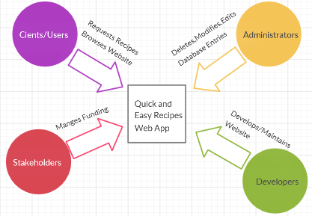

## User Roles

* *Non Registered Clients/Users*
* *Registered Clients/Users*
* *Logged in Users*
* *Logged Out Users*
* *Senior Administrators Full Privileges*
* *Junior Administrators Partial Privileges*

## Business Domain Model

Initial Domain Model

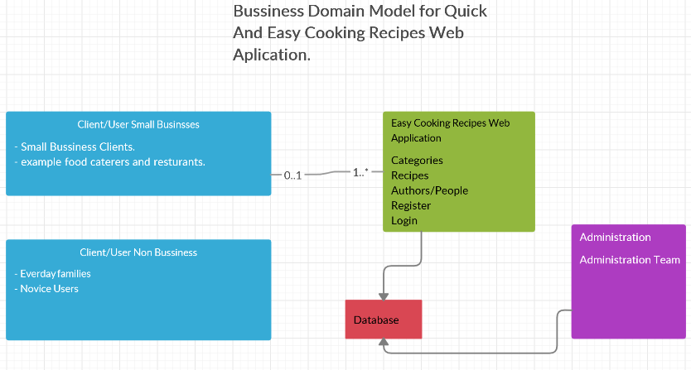

Entity Relationship Diagram (Iteration 3)

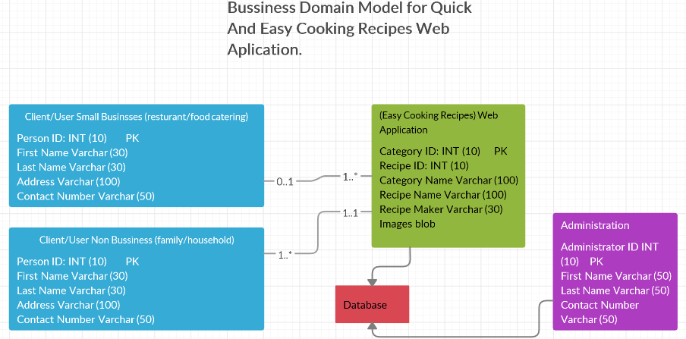

**Description or Definition of each entity**

* *Client/User Small Businesses (restaurant/food catering)*

Has to do with the small business client base that will access the web App to locate recipes for work related requirements to meet the needs of their customers.

* *Client/User Non Business (family/household)*

Has to with family/household clients that access the web App in order to locate food recipes to meet the needs of family and friend.

* *(Quick And Easy Cooking Recipes) Web Application*

The actual Web Application its self has the user interface and is the access point to the database accessed by the clients above.

* *Database*

Holds all the back-end dynamic content for the Web App - Categories, Recipes, Recipe Creators, etc. Accessed by Client base, and Administrators with the access permissions.

* *Administration*

Back-end Hold all the Administration team details allows them privileges to access the database and make needed changes.

## User Stories

Write user stories for that business process including supporting business processes (e.g. data set up, configuration)

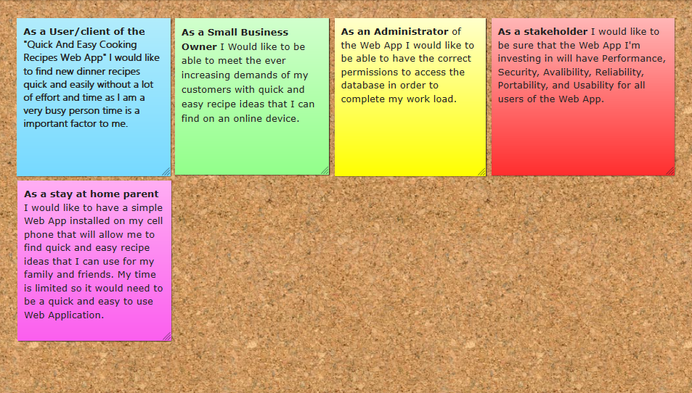

## Non Functional Requirements

### Security requirements

Security Requirements for the (Quick And Easy Cooking Recipes) Web Application

* *Two Factor Authentication for all Users/Clients.*
* *Back-end Set Administrator Privileges and login passwords and Usernames.*
* *Set Registration for Users/Clients with regular up to date renew and reset password functions .*
* *Inform Users/Clients to regularly change their passwords if needed.*
* *Validating user input with error and success messages.*

# Scope

Indicate which requirements you plan to include in the first two iterations. Note that this may change as you advance through the project.

## Iteration 1

List user stories

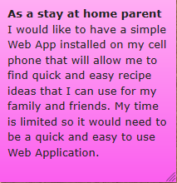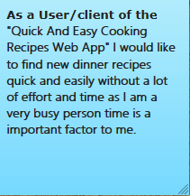

List non-functional requirements

* *Usability “Users/Client would like a Web App that is easy to navigate and easy to learn how to use.*
* *Availability Users/Clients would like to be able to access the Web App on many different devices and it should always be accessible for them.*

## Iteration 2

List user stories

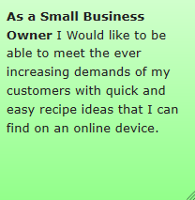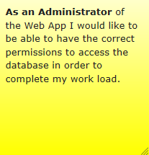

List non-functional requirements

* *Maintainability “Administrators of the Web App would like it to be easy to change solution components for the website Delete,Modify,Edit data. And implement changes without causing failures.”*
* *Performance Efficiency “Clients/Users as well as Administrators would like the speed at which it takes to perform activities to be fast and reliable.*

## Backlog

List explicitly what is not included in the first three iterations

List user stories

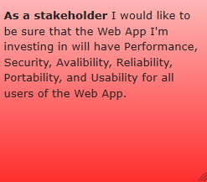

List non-functional requirements

* *Performance Efficiency “Stakeholders would like the speed at which it takes to perform activities to be fast and reliable.”*
* *Security “Stakeholders would like the data in the database to be safe an secure. Two factor authentications. And password and username for Administration. Regular password updates for registered users.”*
* *Availability “Stake holders would like the web App to be at lest 90 percent available at all time for all Users/Clients Administrators etc.”*
* *Reliability “Stakeholders the Web App needs to be reliable and be able to recover from failures and errors.”*
* *Portability “Stakeholders would like the Web App to be multipurpose across many platform such as PC, Hand held devices, etc.”*
* *Usability “Stakeholders would like the Web App to be easy to learn by all Users/Clients”*